Go to your Printer & Scanners settings, you can do this by searching in the Windows search bar:



Clicking on ‘Printers & Scanners’

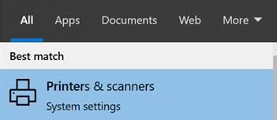

Click on the ‘IntriMail – PDF Hybrid Printer’ and then Click Manage

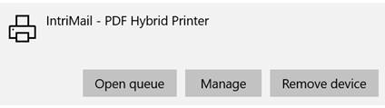

Then click ‘Print Properties’, ‘Advanced’ and then ‘Printing Defaults’, please check that the Predefined Page size is set to A4:

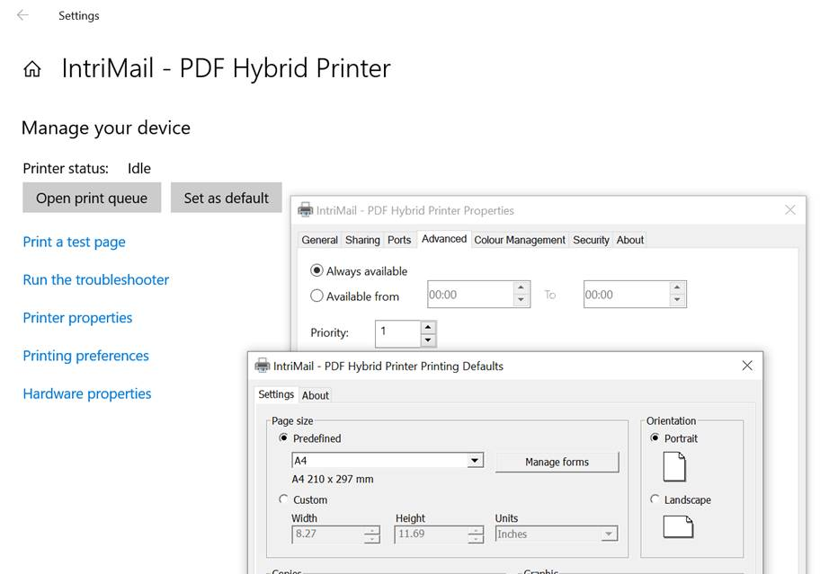

Click ‘OK’ to confirm the settings.

Click ‘Printing Properties’ and check that the page size is set to be defined at A4.